# Guide for Including Pre-Recorded Video

This guide is intended to help you create pre-recorded content for the Rose Show and present it in a professional manner. If you need assistance with these steps, contact Learning and Technology (LearningAndTechnology@rose-hulman.edu) or Professor Reyes ([reyesem@rose-hulman.edu](mailto:reyesem@rose-hulman.edu)).

## Step 1: Create Recording

We recommend using Panopto to create your video content. You can access Panopto at the following address:

<https://rose-hulman.hosted.panopto.com/Panopto/Pages/Home.aspx>

You will be prompted to log in using your Rose-Hulman username and password through Moodle.

Once you are logged in, navigate to “My Folder” (on the left-hand side). Once there, you can create content following the directions on this site:

<https://support.panopto.com/s/article/basic-recording-1>

## Step 2: Share Recording

For the judges and others to see your work, you will need to share the recording. *Note: if you have an NDA in place which prevents you from sharing broadly, it is recommended that you host a live session or consult with your faculty advisor on the best way to disseminate a video presentation.*

The easiest option is sharing the video to be available to “Anyone with the Link” following the instructions given here:

<https://support.panopto.com/s/article/Share-a-Video>

## Step 3: Add Video to Teams

We recommend making the video available in Teams as a separate tab within your channel (to keep it looking professional). Perform the following steps:

1. Navigate to your video in Panopto and open it.
2. Copy the URL associated with your video.
3. Navigate to your Teams Channel.
4. Click the “Plus” button at the top of the channel:  
   
5. From the list of Apps, select “Website” (you can use the search feature if you do not immediately see this app available).  
   
6. In the popup, use “Video Presentation” as the title, paste the URL from step (2) above in the URL box, and uncheck the “Post to the channel about this tab” checkbox.  
   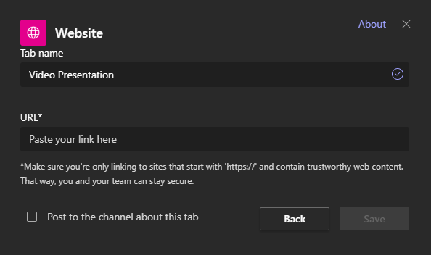

Anyone who clicks on the new tab will pull up your Panopto video within Teams.

## Step 4: Professional-Looking Announcement in Teams

In order to make this tab highly visible, we recommend creating an “Announcement” in your Channel and “pinning” it:

1. Create a Post using the Paragraph editor button (highlighted in the image below). Within the post, highlight the text you would like to use as a link to your presentation and click the link button:  
   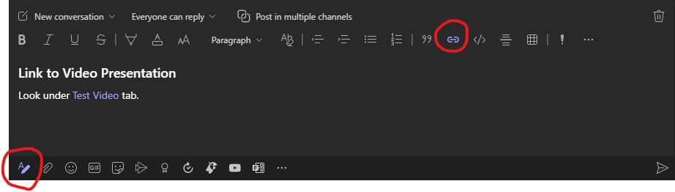
2. To get the URL to your video presentation, click on the tab in your channel hosting the video that you previously created; click on the triple dots to the far right and select “Copy link to tab.”   
   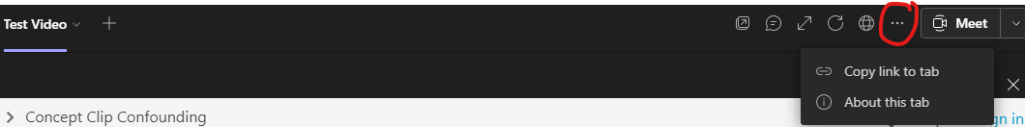
3. Use the drop-down menu in the top-left of the post you are creating to switch from “New Conversation” to “Announcement”:  
   <https://support.microsoft.com/en-gb/office/send-an-announcement-to-a-channel-8f244ea6-235a-4dcc-9143-9c5b801b4992>

This will allow you to create a banner that draws attention to the post.

1. Once created, hover over the post as if you were going to add an emoji reaction; select the triple dots to pull up an extended menu. Select “pin.”  
   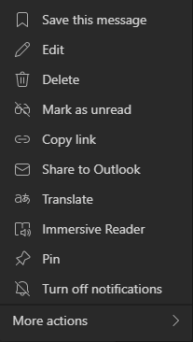
2. This will ensure this post is at the top of the channel as people arrive.